# Creating a new Azure AD 2.0 App Registration for Graph Reports

1. Login to <https://apps.dev.microsoft.com/#/appList>, this is easiest to accomplish as a Global Admin as you can perform all steps.
2. Click the Add an App link next to **Azure AD Only Applications**.
3. Complete the fields required;
   1. Name: **LoginGraphAAD2**
   2. Type: **Native**
   3. Redirect URL: **https://LoginGraphAAD2**
      1. Note: This URL only need to be unique in the organization, it does not need to resolve.
4. When the Edit Application Manifest screen opens after creation, click on the **Edit in the Azure Portal** link.
5. Click on the **Settings** link to open the Settings blade.
6. On the Settings blade, click on **Owners.**
7. On the Owners blade, **add your login ID** and anyone else who may manage/use this App registration.
8. On the Settings blade, click on **Required Permissions.**
9. Click the **Add** button on the Required Permissions blade.
10. Under Select API, choose **Microsoft Graph**
11. Under Select Permissions add **Read all usage reports.**

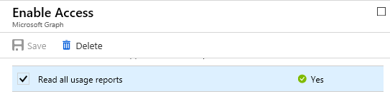

1. ***This step must be completed by a Global Admin for the tenant.***  
   Click the **Grant Permissions** button to grant the requested permissions.